# Risk & Return

# Beta

Beta measures the responsiveness of a security to movements in the market portfolio, i.e., systematic risk

Cov= correlation*stdA*stdB

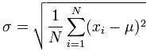

# Cost of Capital

## Cost of Equity, RE

**D1** – Expected dividend in one period; **g** – Dividend growth rate; **P0** – Current stock price; **RE** – Risk-free rate

**Rm** – Expected return on the overall market; **βE** – Systematic risk of the equity

## Cost of Debt, RD

For a firm with public debt, the cost of debt is the yield to maturity on outstanding debt. If the firm has no public debt, use the yield to maturity of similarly rated bonds.

## Weighted Average Cost of Capital, WACC

**TC** – Corporate tax rate; **E** – Market value of the firm’s equity; **D** – Market value of the firm’s debt; **V** = E+D







; **Rd** = Normal interest rate; **Rp** = Cost of preferred stock; **FE**= Equity flotation cost; **FD** = Debt flotation cost





Where Delta are the assets tied directly to sales

**L** are the liabilities tied directly to sales; **S0** is this year’s sales; **∆S** is the change in sales

**S1** is next year’s projected sales; **p** is the profit margin; **RR** is the retention ratio, or (1 – dividend payout ratio)







Sales (Revenues from operations)

- COGS (Cost of goods sold-labor, material, book depreciation)

- SG&A (Selling, general administrative costs)

EBIT (Earnings before interest and taxes or Operating Earnings)

- Taxes (Cash taxes)

EBIAT (Earnings before interest after taxes)

+ DEP (Book depreciation)

- CAPX (Capital expenditures)

- ChgWC (Change in working capital)

= C (Free cash flows)

# Capital Budgeting

## Other Capital Budgeting Techniques

Discounting Approach – Discount negative CF to PV at RRR and add to initial cost.

Reinvestment Approach = Discount pos + neg CF to PV at RRR

Combination – Neg CF discounted to PV, Pos CF compounded to FV

# Random Stuff

## Basic Components of Discount Rate

**Risk-free rate** - Time preferences suggest a positive component to all discount rates.

**Risk Premium** - Risk aversion suggests an additional component representative of the asset's risk

**Risk Premia** - Variation in discount rates across assets

## Stock Returns

)



Where *T* is the forecast horizon and *N* is the number of years of historical data we are working with

*T* must be less than *N*

Expected Return = 

**7**

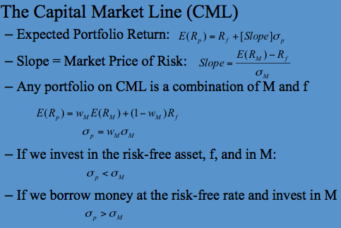

**Arithmetic Average** - Return earned in an average period over multiple periods

**Geometric Average** - Average compound return per period over multiple periods. The geometric average will be less than the arithmetic average unless all the returns are equal